CA 1

QUESTION 1:

1)Verify that the user can add a product to the cart by clicking on the "Add to Cart" button on the product page.

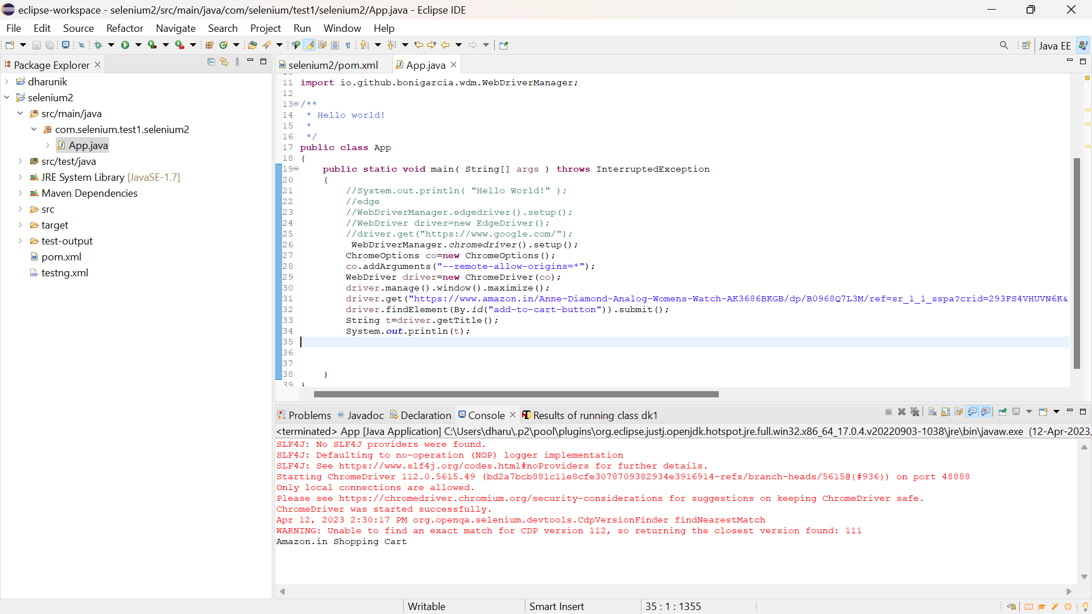

**package** com.selenium.test1.selenium2;

**import** org.openqa.selenium.By;

**import** org.openqa.selenium.JavascriptExecutor;

**import** org.openqa.selenium.WebDriver;

**import** org.openqa.selenium.WebElement;

**import** org.openqa.selenium.chrome.ChromeDriver;

**import** org.openqa.selenium.chrome.ChromeOptions;

**import** org.openqa.selenium.support.ui.Select;

**import** io.github.bonigarcia.wdm.WebDriverManager;

/**

* Hello world!

*

*/

**public** **class** App

{

**public** **static** **void** main( String[] args ) **throws** InterruptedException

{

//System.out.println( "Hello World!" );

//edge

//WebDriverManager.edgedriver().setup();

//WebDriver driver=new EdgeDriver();

//driver.get("https://www.google.com/");

WebDriverManager.*chromedriver*().setup();

ChromeOptions co=**new** ChromeOptions();

co.addArguments("--remote-allow-origins=*");

WebDriver driver=**new** ChromeDriver(co);

driver.get("https://www.amazon.in/");

driver.manage().window().maximize();

String actualTitle=driver.getTitle();

System.***out***.println("Page title is : " + driver.getTitle());

String expectedTitle = "Online Shopping site in India: Shop Online for Mobiles, Books, Watches, Shoes and More - Amazon.in";

**if**(actualTitle.equalsIgnoreCase(expectedTitle))

System.***out***.println("Title Matched");

**else**

System.***out***.println("Title didn't match");

driver.get("https://www.amazon.in/Amazon-Brand-Tealight-Candles-Unscented/dp/B0744P71Y9/ref=sr_1_1?pd_rd_r=c06ef2b7-59da-457e-aa77-aaf7ebd414a2&pd_rd_w=kVt55&pd_rd_wg=vANIH&pf_rd_p=4901d125-0f33-48fa-87d3-a07efd7793cd&pf_rd_r=VSEXK1W6N5BTXD0J3B0H&qid=1681290806&refinements=p_n_format_browse-bin%3A19560799031&s=kitchen&sr=1-1");

driver.findElement(By.*id*("add-to-cart-button")).submit();

String t=driver.getTitle();

System.***out***.println("Added to cart");

}

}

2)Verify that the user can remove a product from the cart by clicking on the "Remove" button next to the product

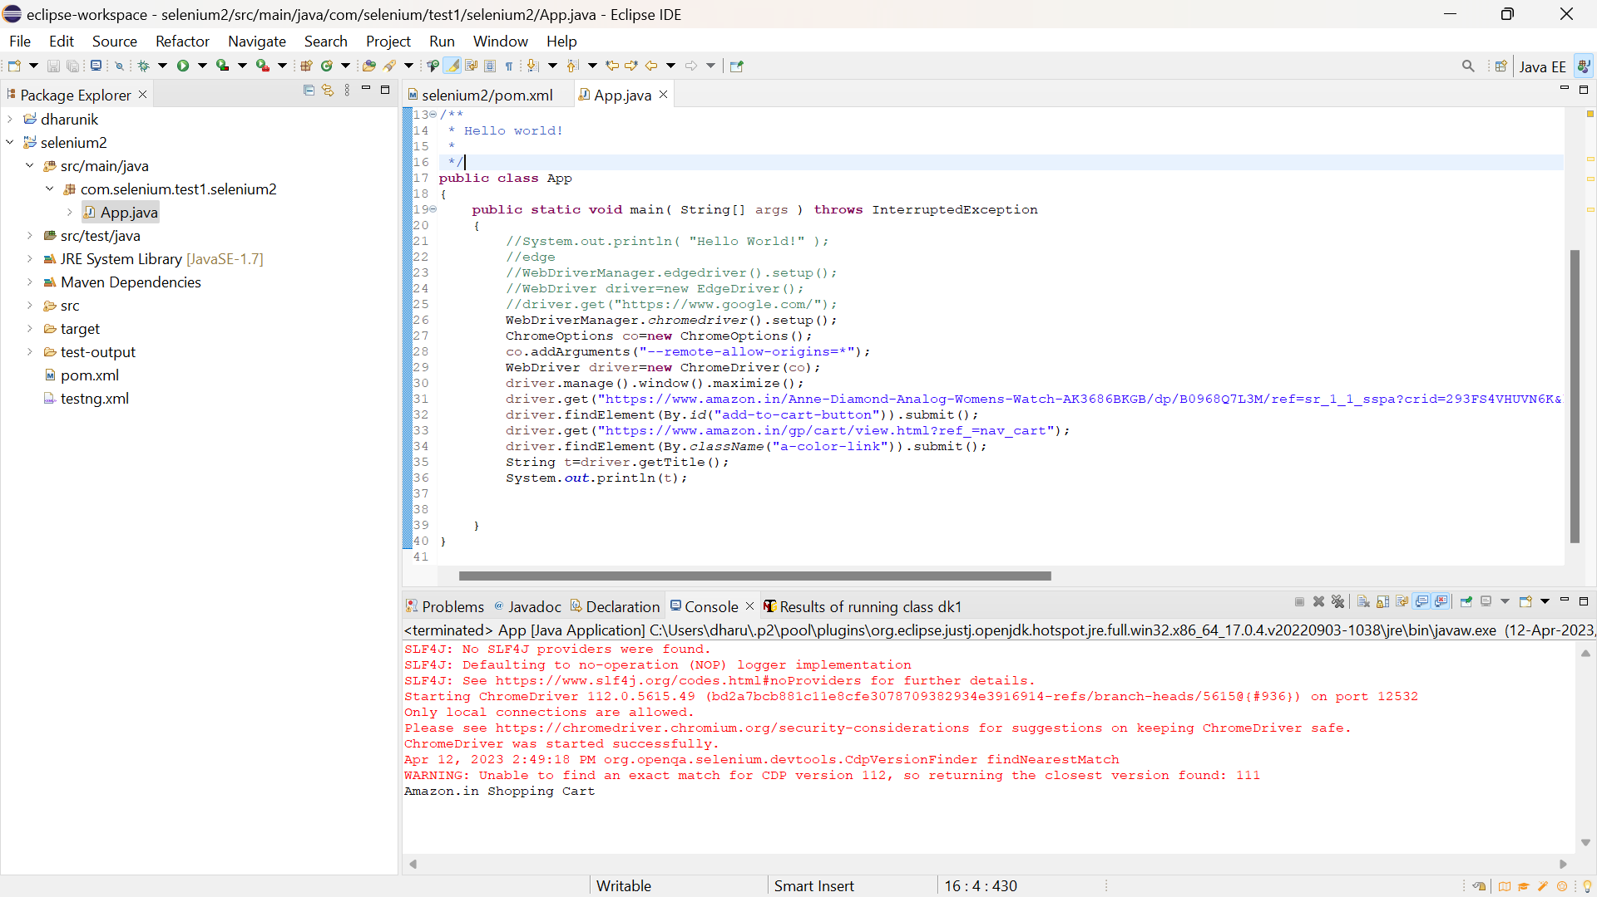

**package** com.selenium.test1.selenium2;

**import** org.openqa.selenium.By;

**import** org.openqa.selenium.JavascriptExecutor;

**import** org.openqa.selenium.WebDriver;

**import** org.openqa.selenium.WebElement;

**import** org.openqa.selenium.chrome.ChromeDriver;

**import** org.openqa.selenium.chrome.ChromeOptions;

**import** org.openqa.selenium.support.ui.Select;

**import** io.github.bonigarcia.wdm.WebDriverManager;

/**

* Hello world!

*

*/

**public** **class** App

{

**public** **static** **void** main( String[] args ) **throws** InterruptedException

{

//System.out.println( "Hello World!" );

//edge

//WebDriverManager.edgedriver().setup();

//WebDriver driver=new EdgeDriver();

//driver.get("https://www.google.com/");

WebDriverManager.*chromedriver*().setup();

ChromeOptions co=**new** ChromeOptions();

co.addArguments("--remote-allow-origins=*");

WebDriver driver=**new** ChromeDriver(co);

driver.manage().window().maximize();

driver.get("https://www.amazon.in/Anne-Diamond-Analog-Womens-Watch-AK3686BKGB/dp/B0968Q7L3M/ref=sr_1_1_sspa?crid=293FS4VHUVN6K&keywords=watches&qid=1681287782&sprefix=watches%2Caps%2C323&sr=8-1-spons&sp_csd=d2lkZ2V0TmFtZT1zcF9hdGY&psc=1");

driver.findElement(By.*id*("add-to-cart-button")).submit();

driver.get("https://www.amazon.in/gp/cart/view.html?ref_=nav_cart");

driver.findElement(By.*className*("a-color-link")).submit();

String t=driver.getTitle();

System.***out***.println(t);

}

}

3. Verify that the user can update the quantity of a product in the cart by changing the quantity and clicking on the "Update" button.

**package** com.selenium.test1.selenium2;

**import** org.openqa.selenium.By;

**import** org.openqa.selenium.WebDriver;

**import** org.openqa.selenium.WebElement;

**import** org.openqa.selenium.chrome.ChromeDriver;

**import** org.openqa.selenium.chrome.ChromeOptions;

**import** org.openqa.selenium.support.ui.Select;

**import** io.github.bonigarcia.wdm.WebDriverManager;

/**

* Hello world!

*

*/

**public** **class** App

{

**public** **static** **void** main( String[] args ) **throws** InterruptedException

{

WebDriverManager.chromedriver().setup();

ChromeOptions co=**new** ChromeOptions();

co.addArguments("--remote-allow-origins=*");

WebDriver driver=**new** ChromeDriver(co);

driver.manage().window().maximize();

driver.get("https://www.amazon.in/Anne-Diamond-Analog-Womens-Watch-AK3686BKGB/dp/B0968Q7L3M/ref=sr_1_1_sspa?crid=293FS4VHUVN6K&keywords=watches&qid=1681287782&sprefix=watches%2Caps%2C323&sr=8-1-spons&sp_csd=d2lkZ2V0TmFtZT1zcF9hdGY&psc=1");

driver.findElement(By.id("add-to-cart-button")).submit();

String t=driver.getTitle();

System.out.println(t);

String cart=driver.findElement(By.xpath("//*[@id=\"NATC_SMART_WAGON_CONF_MSG_SUCCESS\"]/span")).getText();

**if**(cart.equals("Added to cart"));

System.out.println("1. Verified that Product added to cart ");

driver.navigate().back();

WebElement sort1=driver.findElement(By.xpath("//*[@id=\"quantity\"]"));

sort1.click();

Select select=**new** Select(sort1);

select.selectByIndex(1);

String drop=driver.findElement(By.xpath("//*[@id=\"quantity\"]")).getText();

**if**(drop.equals("2"));

System.out.println("3. Verified that Product is updated to cart ");

    }

}

4.Verify that the user can proceed to the checkout page by clicking on the "Checkout" button on the cart page.

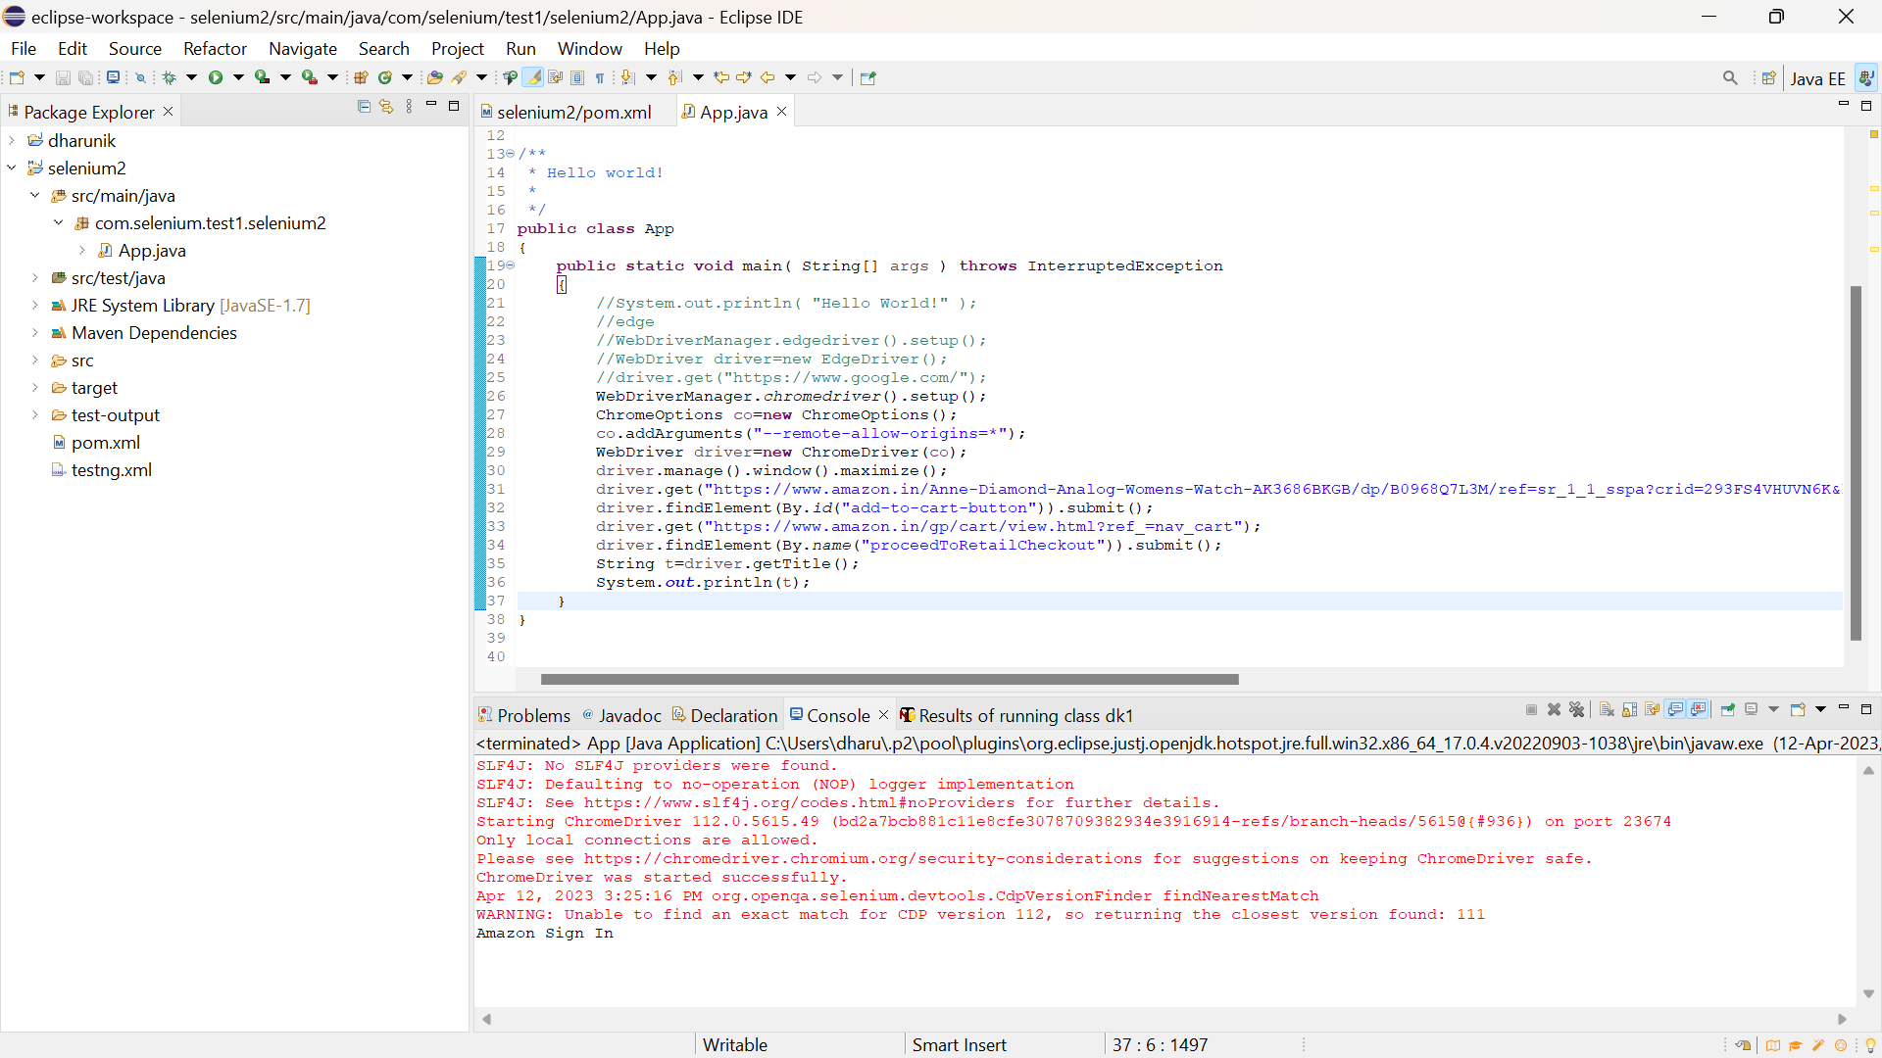

**package** com.selenium.test1.selenium2;

**import** org.openqa.selenium.By;

**import** org.openqa.selenium.JavascriptExecutor;

**import** org.openqa.selenium.WebDriver;

**import** org.openqa.selenium.WebElement;

**import** org.openqa.selenium.chrome.ChromeDriver;

**import** org.openqa.selenium.chrome.ChromeOptions;

**import** org.openqa.selenium.support.ui.Select;

**import** io.github.bonigarcia.wdm.WebDriverManager;

/**

* Hello world!

*

*/

**public** **class** App

{

**public** **static** **void** main( String[] args ) **throws** InterruptedException

{

//System.out.println( "Hello World!" );

//edge

//WebDriverManager.edgedriver().setup();

//WebDriver driver=new EdgeDriver();

//driver.get("https://www.google.com/");

WebDriverManager.*chromedriver*().setup();

ChromeOptions co=**new** ChromeOptions();

co.addArguments("--remote-allow-origins=*");

WebDriver driver=**new** ChromeDriver(co);

driver.manage().window().maximize();

driver.get("https://www.amazon.in/Anne-Diamond-Analog-Womens-Watch-AK3686BKGB/dp/B0968Q7L3M/ref=sr_1_1_sspa?crid=293FS4VHUVN6K&keywords=watches&qid=1681287782&sprefix=watches%2Caps%2C323&sr=8-1-spons&sp_csd=d2lkZ2V0TmFtZT1zcF9hdGY&psc=1");

driver.findElement(By.*id*("add-to-cart-button")).submit();

driver.get("https://www.amazon.in/gp/cart/view.html?ref_=nav_cart");

driver.findElement(By.*name*("proceedToRetailCheckout")).submit();

String t=driver.getTitle();

System.***out***.println(t);

}

}

QUESTION 2:

1. Verify that the user can search any product on website and the corresponding search product details needs to be displayed

**package** com.selenium.test1.selenium2;

**import** org.openqa.selenium.By;

**import** org.openqa.selenium.JavascriptExecutor;

**import** org.openqa.selenium.WebDriver;

**import** org.openqa.selenium.WebElement;

**import** org.openqa.selenium.chrome.ChromeDriver;

**import** org.openqa.selenium.chrome.ChromeOptions;

**import** org.openqa.selenium.support.ui.Select;

**import** io.github.bonigarcia.wdm.WebDriverManager;

/**

* Hello world!

*

*/

**public** **class** App

{

**public** **static** **void** main( String[] args ) **throws** InterruptedException

{

//System.out.println( "Hello World!" );

//edge

//WebDriverManager.edgedriver().setup();

//WebDriver driver=new EdgeDriver();

//driver.get("https://www.google.com/");

WebDriverManager.chromedriver().setup();

ChromeOptions co=**new** ChromeOptions();

co.addArguments("--remote-allow-origins=*");

WebDriver driver=**new** ChromeDriver(co);

driver.get("https://www.amazon.com/");

driver.manage().window().maximize();

System.out.println("Page Title: " + driver.getTitle());

String name = driver.getTitle();

System.out.println(name);

String title = "Online Shopping site in India: Shop Online for Mobiles, Books, Watches, Shoes and More - Amazon.in";

**if**(name.equals(title)) {

System.out.println("Validated Page Title");

}

driver.findElement(By.id("twotabsearchtextbox")).sendKeys("bag");

driver.findElement(By.id("nav-search-submit-button")).click();

String expectedSearchTitle = "Amazon.com : bag";

String actualSearchTitle = driver.getTitle();

**if** (actualSearchTitle.contains(expectedSearchTitle)) {

System.out.println("Search is successfull");

} **else** {

System.out.println("Search is failed!");

}

driver.quit();

    }

}

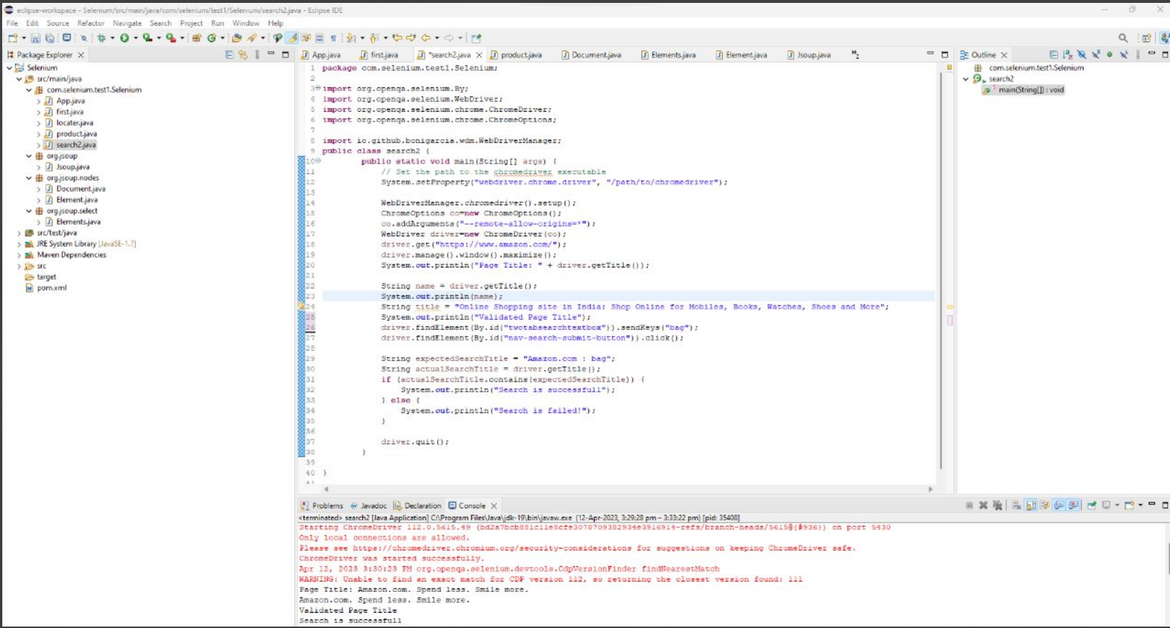

2. Print minimum 5 Names of the products displayed on the webpage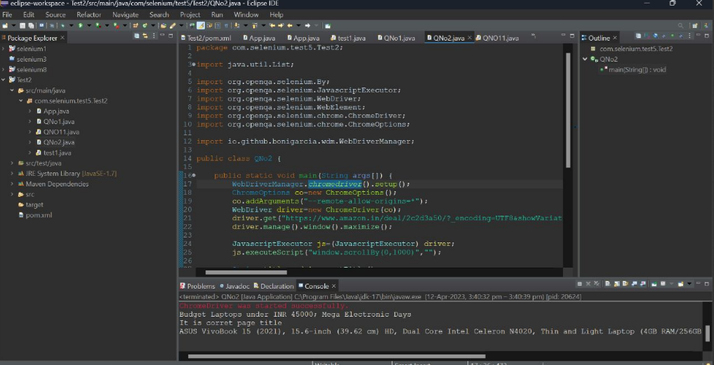

**package** com.selenium.test1.selenium2;

**import** java.util.List;

**import** org.openqa.selenium.By;

**import** org.openqa.selenium.JavascriptExecutor;

**import** org.openqa.selenium.WebDriver;

**import** org.openqa.selenium.WebElement;

**import** org.openqa.selenium.chrome.ChromeDriver;

**import** org.openqa.selenium.chrome.ChromeOptions;

**import** io.github.bonigarcia.wdm.WebDriverManager;

/**

* Hello world!

*

*/

**public** **class** App

{

**public** **static** **void** main( String[] args ) **throws** InterruptedException

{

WebDriverManager.chromedriver().setup();

ChromeOptions co=**new** ChromeOptions();

co.addArguments("--remote-allow-origins=*");

WebDriver driver=**new** ChromeDriver(co);

driver.get("https://www.amazon.in/deal/2c2d3a50/?encoding=UTF8&showVariations=true&_ref=dlx_gate_sd_dcl_tlt_2c2d3a50_dt&pd_rd_w=YgMyt&content-id=amzn1.sym.a532052b-26f3-4811-a261-3b35ffa57237&pf_rd_p=a532052b-26f3-4811-a261-3b35ffa57237&pf_rd_r=SWJFXC5PAM03PF4G0AWT&pd_rd_wg=6zviy&pd_rd_r=1f436e7b-ab36-4c27-9e50-8f8c69db422a&ref=pd_gw_unk");

driver.manage().window().maximize();

JavascriptExecutor js=(JavascriptExecutor) driver;

js.executeScript("window.scrollBy(0,1000)","");

String title = driver.getTitle();

System.out.println(title);

String title2="Budget Laptops under INR 45000; Mega Electronic Days";

//title2=driver.getTitle();

**if**(title2.equals(title)) {

System.out.println("It is corret page title");

}

List<WebElement> li=driver.findElements(By.xpath("//*[@id=\"octopus-dlp-asin-stream\"]/ul/li[3]/span/div/div[2]/div[1]/a"]"));"

**for**(WebElement link:li) {

System.out.println(link.getText());

}

driver.navigate().back();

driver.navigate().forward();

driver.navigate().refresh();

driver.quit();

}

}

3)Verify that the user can filter the search results by category, price, and other parameters.

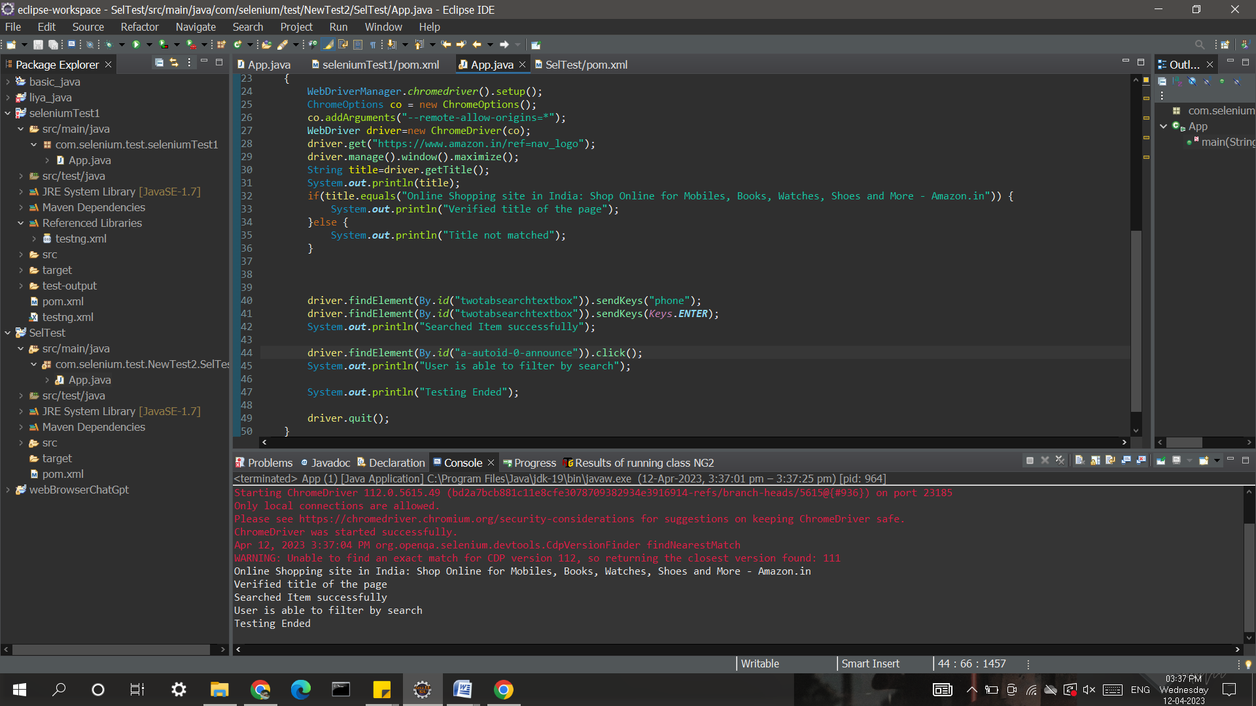

package com.selenium.test.NewTest2.SelTest;

import java.util.List;

import org.openqa.selenium.By;

import org.openqa.selenium.JavascriptExecutor;

import org.openqa.selenium.Keys;

import org.openqa.selenium.WebDriver;

import org.openqa.selenium.WebElement;

import org.openqa.selenium.chrome.ChromeDriver;

import org.openqa.selenium.chrome.ChromeOptions;

import org.openqa.selenium.support.ui.Select;

import io.github.bonigarcia.wdm.WebDriverManager;

public class App

{

public static void main( String[] args ) throws InterruptedException

{

WebDriverManager.chromedriver().setup();

ChromeOptions co = new ChromeOptions();

co.addArguments("--remote-allow-origins=*");

WebDriver driver=new ChromeDriver(co);

driver.get("https://www.amazon.in/ref=nav_logo");

driver.manage().window().maximize();

String title=driver.getTitle();

System.out.println(title);

if(title.equals("Online Shopping site in India: Shop Online for Mobiles, Books, Watches, Shoes and More - Amazon.in")) {

System.out.println("Verified title of the page");

}else {

System.out.println("Title not matched");

}

driver.findElement(By.id("twotabsearchtextbox")).sendKeys("phone");

driver.findElement(By.id("twotabsearchtextbox")).sendKeys(Keys.ENTER);

System.out.println("Searched Item successfully");

driver.findElement(By.id("a-autoid-0-announce")).click();

List<WebElement>li=driver.findElements(By.xpath("//*[@id=\"octopus-dlp-asin-stream\"]/ul/li[2]/span/div/div[2]/div[1]/a"));

for(WebElement link:li) {

System.out.println(link.getText());

}

System.out.println("User is able to filter by search");

System.out.println("Testing Ended");

driver.quit();

}

}

QUESTION 3:

1.Verify that the once the user clicks on You account link,”Your account page” is displayed

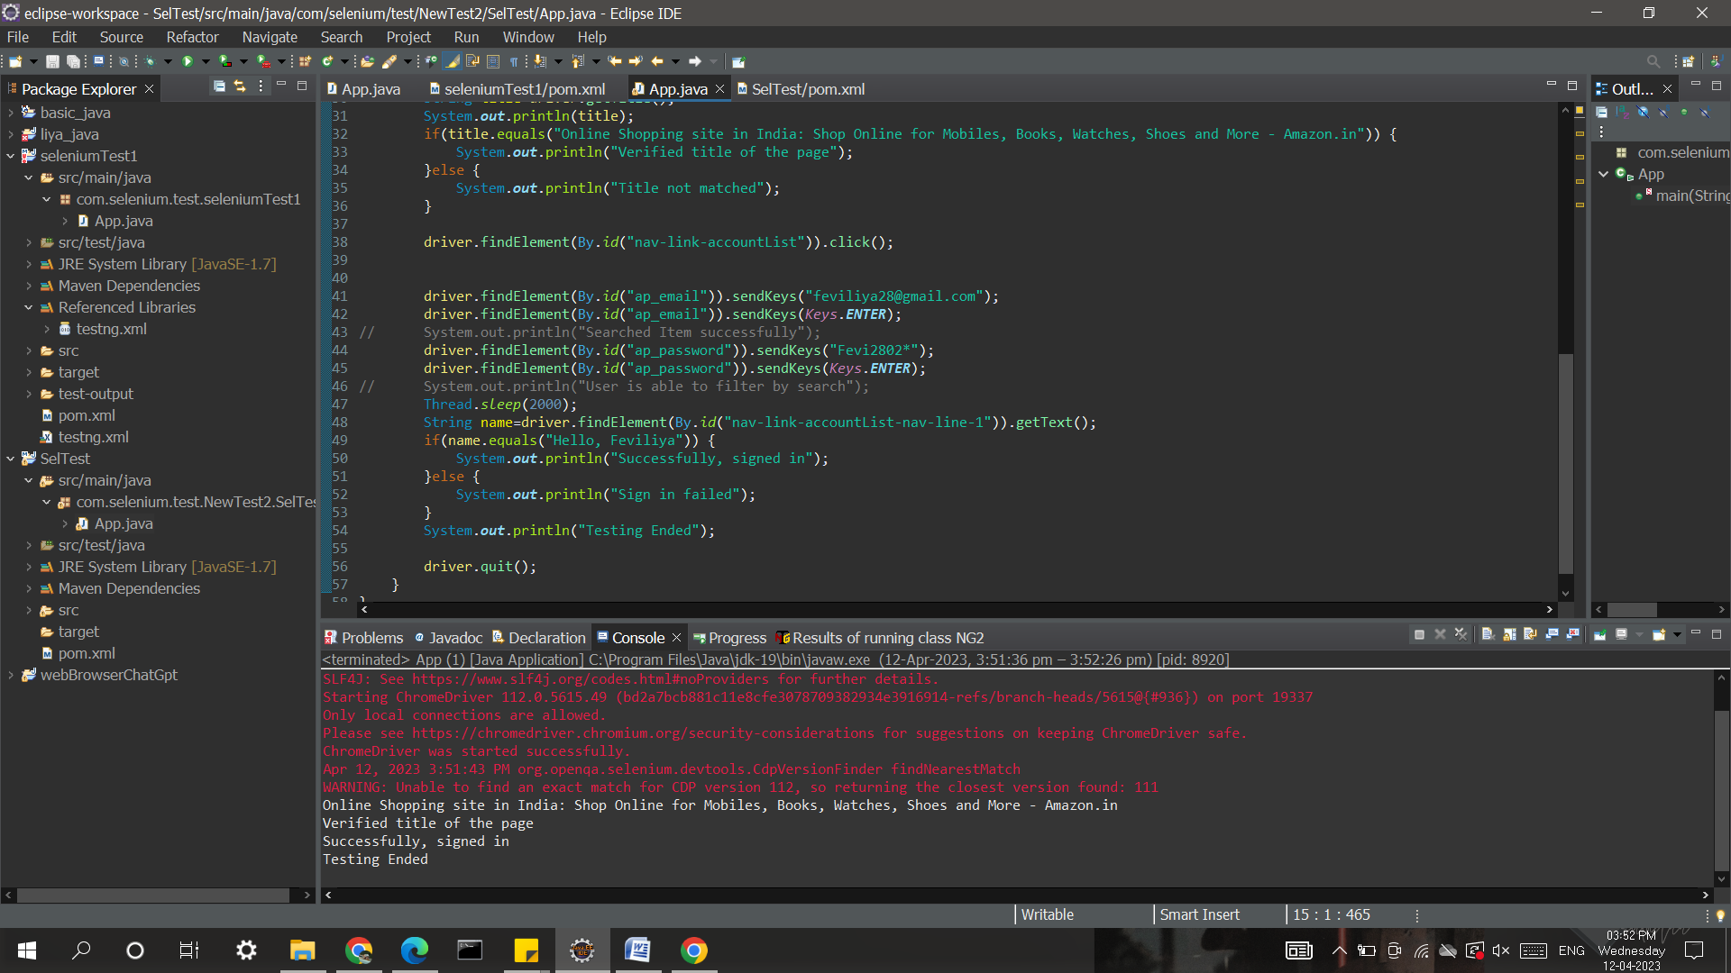

package com.selenium.test.NewTest2.SelTest;

import java.util.List;

import org.openqa.selenium.By;

import org.openqa.selenium.JavascriptExecutor;

import org.openqa.selenium.Keys;

import org.openqa.selenium.WebDriver;

import org.openqa.selenium.WebElement;

import org.openqa.selenium.chrome.ChromeDriver;

import org.openqa.selenium.chrome.ChromeOptions;

import org.openqa.selenium.support.ui.Select;

import io.github.bonigarcia.wdm.WebDriverManager;

/**

* Hello world!

*

*/

public class App

{

public static void main( String[] args ) throws InterruptedException

{

WebDriverManager.chromedriver().setup();

ChromeOptions co = new ChromeOptions();

co.addArguments("--remote-allow-origins=*");

WebDriver driver=new ChromeDriver(co);

driver.get("https://www.amazon.in/ref=nav_logo");

driver.manage().window().maximize();

String title=driver.getTitle();

System.out.println(title);

if(title.equals("Online Shopping site in India: Shop Online for Mobiles, Books, Watches, Shoes and More - Amazon.in")) {

System.out.println("Verified title of the page");

}else {

System.out.println("Title not matched");

}

driver.findElement(By.id("nav-link-accountList")).click();

driver.findElement(By.id("ap_email")).sendKeys("dk@gmail.com");

driver.findElement(By.id("ap_email")).sendKeys(Keys.ENTER);

driver.findElement(By.id("ap_password")).sendKeys("dk*");

driver.findElement(By.id("ap_password")).sendKeys(Keys.ENTER);

Thread.sleep(2000);

String name=driver.findElement(By.id("nav-link-accountList-nav-line-1")).getText();

if(name.equals("Hello, dk")) {

System.out.println("Successfully, signed in");

}else {

System.out.println("Sign in failed");

}

System.out.println("Testing Ended");

driver.quit();

}

}

2.Verify that user is able to track/view the orders by clicking on “Your order”.

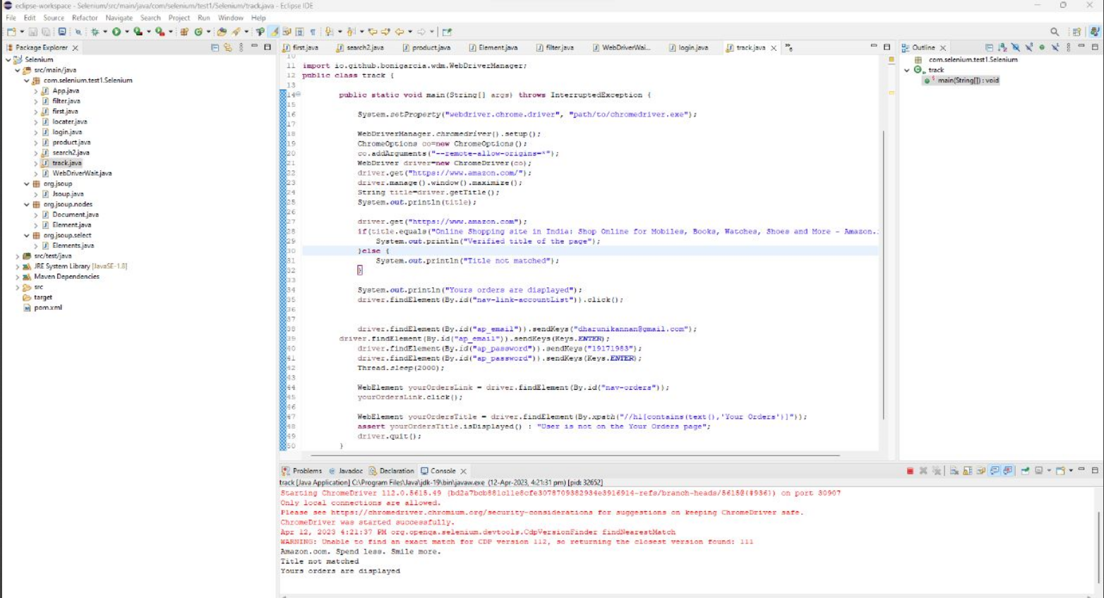

package com.selenium.test1.Selenium;

import org.openqa.selenium.By;

import org.openqa.selenium.Keys;

import org.openqa.selenium.Keys;

import org.openqa.selenium.WebDriver;

import org.openqa.selenium.WebElement;

import org.openqa.selenium.chrome.ChromeDriver;

import org.openqa.selenium.chrome.ChromeOptions;

import io.github.bonigarcia.wdm.WebDriverManager;

public class track {

public static void main(String[] args) throws InterruptedException {

System.setProperty("webdriver.chrome.driver", "path/to/chromedriver.exe");

WebDriverManager.chromedriver().setup();

ChromeOptions co=new ChromeOptions();

co.addArguments("--remote-allow-origins=*");

WebDriver driver=new ChromeDriver(co);

driver.get("https://www.amazon.com/");

driver.manage().window().maximize();

String title=driver.getTitle();

System.out.println(title);

driver.get("https://www.amazon.com");

if(title.equals("Online Shopping site in India: Shop Online for Mobiles, Books, Watches, Shoes and More - Amazon.in")) {

System.out.println("Verified title of the page");

}else {

System.out.println("Title not matched");

}

driver.findElement(By.id("nav-link-accountList")).click();

driver.findElement(By.id("ap_email")).sendKeys("dharunikannan@gmail.com");

driver.findElement(By.id("ap_email")).sendKeys(Keys.ENTER);

driver.findElement(By.id("ap_password")).sendKeys("19171983");

driver.findElement(By.id("ap_password")).sendKeys(Keys.ENTER);

Thread.sleep(2000);

WebElement yourOrdersLink = driver.findElement(By.id("nav-orders"));

yourOrdersLink.click();

WebElement yourOrdersTitle = driver.findElement(By.xpath("//h1[contains(text(),'Your Orders')]"));

assert yourOrdersTitle.isDisplayed() : "User is not on the Your Orders page";

System.out.println("Yours orders are displayed");

driver.quit();

    }

}